BUCK
Parish Records
1788 Mary BUCK as wife of Marmaduke WARD - clerk
1818 Mary BUCK married William Brown
1825 Elizabeth BUCK as wife of James Self
1845 Virtue bap F Benjamin shop keeper M Elizabeth
1849 George Miles bap F Benjamin carpenter M Elizabeth Alice
1871 Virtue BUCK married Henry Bugden May farmer Witnesses Benjamin & Harriet BUCK
1902 Elizabeth Alice died aged 82 churchyard grave wife of Benjamin
1907 Benjamin died aged 88 churchyard grave
1909 Sarah Ann died aged 78 wife of Robert churchyard grave
1929 Robert died aged 87 widower of Sarah Ann churchyard grave

Cemetery
Sidney Walter BUCK 1899-1992 and wife Maud Ellen BUCK 1904-1978

Churchyard
62 20.08.1907 Benjamin BUCK 88
07.12.1902 Elizabeth Alice BUCK 82
In memory of Elizabeth Alice the dearly loved wife of Benjamin Buck born 9th December 1820 died 7th December 1902 Also Benjamin Buck [....] August 20 1907 aged 88 years

186 25.02.1929 Robert BUCK 87
10.09.1909 Sarah Ann BUCK 78
In loving memory of Sarah Ann Buck wife of Robert Buck who died 10th Sept. 1909 aged 78 years And there shall be no more death neither sorrow nor crying neither shall there be any more pain Also Robert Buck who died 25th Feb. 1929 aged 87 years He giveth his beloved sleep

Newspapers
1834 Norfolk Chronicle 12 Apr sale Three tenements with a wheelwrights shop, stable yard and ground near the church and now in the occupation of BECKERSON, Thomas BUCK,

1863 Norfolk News 26 Sept Marriages On Tuesday last at St Nicholas Church, Great Yarmouth Mr Edward CHAPMAN to Virtue, only daughter of Mr Benjamin BUCK, Trunch

1864 Norfolk News 1 Oct North Walsham session Robert CHAPMAN harness maker of Trunch sued by Benjamin BUCK shopkeeper for 1s11d for goods sold and use of well. Defense said plaintiff had no right to charge parishioners of Trunch for the use of the well ....that no one had any title to the well except Lord Suffield. The plaintiff said he had management of the well for 20 years but was told by his honour that that gave him no right to sue. The case was struck out with expenses

1864 Norwich Mercury 5 Nov sale four substantial and nearly new brick and tile cottages and large grocers shop together with yards and gardens in the several occupation of Benjamin BUCK and others.

1866 Norfolk Chronicle 11 Aug Petty sessions Benjamin BUCK of Trunch charged on the info of Wm Roofe of Skeyton, overseer with refusing to pay the poor’s rate was ordered to pay 6s 1.5d and costs 17s.

1875 Norfolk Chronicle 17 April summons Benjamin BUCK shopkeeper v James BOULTER labourer, unpaid balance £6 14s 9d Boulter hadn’t paid. Committed for 28 days suspended for a month, would not be enforced if he paid 10s a month

1880 Norwich Mercury 26 June Benjamin BUCK, shopkeeper sued William FRAREY of Wroxham, labourer for £5 6s 6d balance of account for grocery goods alleged to have been supplied. The account attached was a voluminous document. The defendants wife said she had not had the goods. Judge not happy with the accounts.

1880 Norwich Mercury 28 Aug Benjamin BUCK shopkeeper v William FRAREY, maltster Wroxham Judge again thought the “books were cooked” Non suit entered

1881 Norwich Mercury 13 Aug The Primitive Methodists first Sunday school anniversary was celebrated on the 31st. Sunday school opened thanks to the energy of Mrs NICHOLS, Mr COLEMAN, Mr FLAXMAN, Mr PITT and others. A large room was lent by Mr BUCK. Mr T BEALEY played the harmonium. On Wed the children had their treat. Waggons and horses were lent by Mr BIDWELL, Mr BUCK

1882 Norwich Mercury 15 Feb Robert BUCK farm baliff charged by John Blanchflower a farmer at Knapton with using a trap for the purpose of taking game on land of Mrs Clarke Knapton. Ordered to pay £1 5s

1887 Norwich Mercury 26 Feb Robert BUCK farmer sued Press Bros merchants of N Walsham for £2 4s 7d paid to GER for conveyance of barley Dispute about quality etc Judge believed plaintiff. So Press Bros ordered to pay.

1888 EDP 8 Aug Primitive Methodist Sunday School anniversary on Sunday July 29th. Celebrated in a large barn kindly lent by Mr BUCK which was handsomely decorated with flowers etc and filled to overflowing.

1888 Norfolk Chronicle 1 Sept Cottages occupied by Rebecca COLEMAN and John PRIEST at £4 10s per year bought by B Buck for £36

1890 EDP 11 March Benjamin BUCK was charged with allowing one of his cottages to be in such a state as to constitute a nuisance. The evidence of Mr Kemp & Dr Shephard Taylor was to the effect that there was not sufficient room to provide necessary accommodation. It would be difficult to do anything to make the premises fit for human habitation. The bench made an order for the cottage to be closed.

1892 Thetford & Watton Times 20 Feb On Mon last the Old Hall narrowly escaped destruction. Mr Robert BUCK in going upstairs into a spare room found the floor on fire. He obtained assistance and extinguished the flames before much damage had been done.

1893 Norwich Mercury 1 April Vicar refused to allow meeting to nominate village overseers in the church, although it had been held there before. He kept the key. Also lecture in Wesleyan Chapel on Rev George Whitfield. Chapel decorated by Mrs NICHOLLS. Miss BUCK sang.

1893 Eastern Evening News 1 April Letter from Benjamin BUCK - I did not arrange with the rector, as he says, to hold the meeting in the school room. What I said was that the meeting must be held in the usual place (the church) and if the rate-payers pleased they might adjourn to the school-room. I believe the ink stains on the Communion table were occasioned at a wedding.

1893 EDP 25 May Sale Manor House and farm of James WALPOLE deceased, 80 acres, occupied by Robert BUCK at a rental of £112

1894 Norwich Mercury 2 June Respected postmaster Benjamin BUCK entertained 73 village children to an excellent tea in a tastefully decorated barn on the farm occupied by Henry May to commemorate his golden wedding. After tea the youngsters indulged in football, scrambling for nuts etc and before leaving cheered heartily for Mr & Mrs BUCK. Friends and neighbours were invited by Mr MAY (son-in-law) to supper in the barn.

1894 Thetford & Watton Times 30 June Benjamin BUCK, shopkeeper, sued Edward WEGG, brickmaker, for £1 15s half year rent for a cottage. Wegg didn’t consider he owed anything, dispute over who had the key. Judge found for Wegg said Buck was bad hearted and had behaved badly, should have taken quarter rent offered him.

1895 Norwich Mercury 10 Aug Benjamin BUCK sued John Lines of Skeyton, rabbit catcher for £4 10s rent. Lines said house in bad state of repair but ordered to pay

1899 Norwich Mercury 4 March Service in Wesleyan Chapel “Singing Joe” Miss BUCK in harmonium,

1900 Lot 12 Four cottages situated in the centre of Trunch. Rental £20 Benjamin BUCK £200
Register of electors
Buck benjamin | 1876-07 | Trunch | Freehold house | Near school
Buck george miles | 1912-13 | St. Brelade, Park Wood Road, Boscombe Park, Bournemouth | Freehold houses | The Hill
Buck robert | 1885 only | Trunch | £50 a year occupier | Mundesley Road
Buck william | 1856-64 | North Walsham | CH house and garden | Front of church
Buck william | 1855&56 | Skeyton | CH house and garden | Front of church
1920 electors
Buck | Emma
Buck | Fred
Buck | Robert
Buck | Sidney Walter

Sidney Walter BUCK born 1899, in Trunch, Mundesley Road. Horseman Single in 1917 Next of kin - Mrs Emma Buck., mother. TR/10/30817 Training Reserve 32nd. Battalion 1917 aged 18 48533 2nd. Battalion Wounded 18.06.1918
Offence Hagley Down 11.06.19 absent without leave for 1 day punishment administered - forfeit ??? Dorset Regiment
1901 with father Fred (31, farm steward), mother Emma (32) in Stratton Strawless where it is said he was born
1911 with father Fred, horseman mother Emma in Trunch says all 3 were born in Swanton Abbot

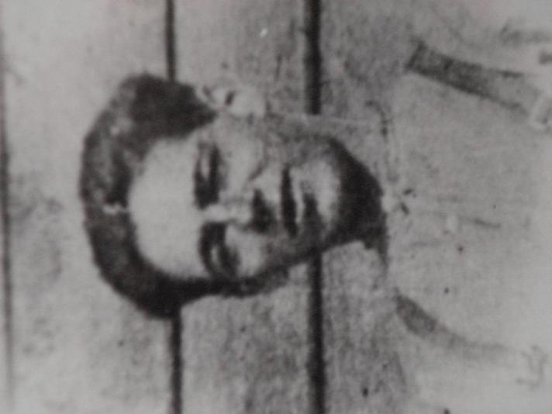

Sidney Buck

1939 register

Chapel Road 49 | Buck | Sydney W | May-20 | 1899 | M | Farm labourer
Chapel Road 49 | Buck | Maud E | Feb-19 | 1902 | M | Unpaid home duties
Chapel Road 44 | Buck | Fred | Sep-11 | 1869 | M | Agricultural labourer - retired
Chapel Road 44 | Buck | Emma S | Mar-22 | 1868 | M | Unpaid home duties

Buck | Sidney Walter | 1992 | Cosy Nook, Chapel Road | 1.06.1992 | Ipswich | 14-Apr | < £125,000

